Summary for pre-read

WBR - Summary (for Pre-Read)
1) DLD Market
Overall market transaction value remains ~24% lower vs previous year, driven more by Secondary than Primary. Leading indicators including Form F and Rentals also remain lower compared to pre-conflict levels, suggesting no major sentiment improvement yet.
2) Commercial
Sales Forecast: AED 46.4M vs 70.7M target (66% FC for March, upside to 67%). Continuation of hostilities resulting in more downside and reducing upside. Similar levels expected for April. Concerns around cashflow remain top of client minds.
Net Exclusive Listings: Overall declining trend in past few weeks. This week’s number has scraping challenges, hence not displayed
3) Demand
SoS: Overall SoS at 52.3% (-1.6pp vs 53.9% target, +2.4pp WoW). App SoS at 57.1% (+1.2pp above 55.9% target, +6.1pp WoW). Web SoS at 45.2% (-4.8pp vs 50% target, -3.1pp WoW). App SoS recovering strongly; Web SoS declining.
SEO SoV: Total at 45.8% (flat WoW). Buy 63.8% (+1.1pp WoW); Rent 53.3% (+0.2pp WoW). Generic 35.4% (+2.5pp WoW). MtD Total at 45.4% (+3.8pp vs prior month).
Exposure LPL: Both segments in significant decline vs pre-conflict levels. Rent eLPL at 7.1 (vs Target of 11), driven by sharp drop in leads (-43%) while listings remained flat (-3%). Buy eLPL at 3.7 (vs target of 7.6), driven by -51% drop in leads. Q2 eLPL targets to be reset;
4) New Projects (Primary)
New Projects gross revenue ($116.2K) at 89% of weekly target (-13.7% WoW). Sessions at 50.5K vs 87K target (-14.3% WoW). Sold Leads at 1,302 vs 1,787 target (-13.7% WoW). All metrics in red, impacted by lower demand due to conflict. MtD revenue at $374.6K (65% of $578.2K target, +34.9% YoY). Expected March achievement: Sessions 60%, Sold Leads 75%, Revenue 95%.
5) B2C App
App ratings: Android saw an uptick due to Google removing 3-star spam ratings and increased 5-star ratings from solicitation updates. iOS ratings stabilising with no new negatives and +0.11% increase in 5-star ratings.
App installs at 23.4K (+66% vs 14.1K target, +39.4% YoY).
DAU at 51.6K (flat WoW).
WAU at 196.2K (+5.1% WoW).
MAU at 438.8K (-1.9% WoW).
6) B2C Tech
Mobile INP Good Rate at 72.5%, stable above the 72% target (+0.5pp WoW). Sustained performance improvements across search templates over the past 6 weeks. Metric now stable above target with no systemic degradation. Focus on maintaining ≥72% and progressing toward 75% by end of Q2.
Appdex Score: Both iOS and Android are above the criteria of 95%
7) B2B Performance
Incident Volume: P0: 1 (vs 6 target), P1: 16 (vs 73 target). Both well below monthly targets.
B2B Agent App: App active agents at 11,452 (-19.9% vs 14,297 target, +0.1% WoW). WAU at 2,755 (-46.5% vs 5,155 target, -14.7% WoW). Both metrics remain under target with WAU continuing to decline.

DLD Market Growth

Property Finder
Weekly Business Review

Market (Dubai)
Secondary market tx. value further down vs last week. Form Fs and leads also declined. Primary market declined in value terms, yet sustain vs pre-conflict level along vol. Terms. Though significant decline in Primary leads, suggests potential for further reduction in future weeks.

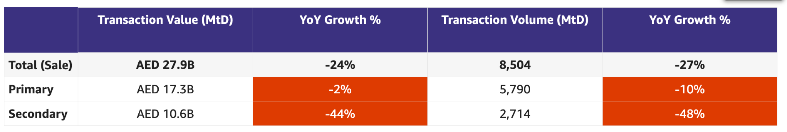

Below table has daily average values for weekdays only (except leads, which is for all days)
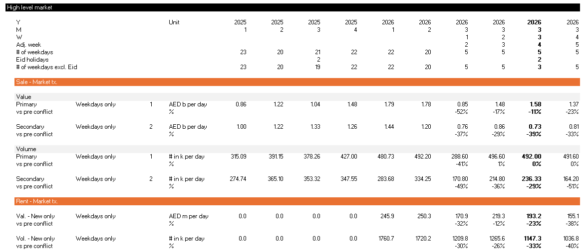

Action: Draw parallels from market contraction during Eid 2025 vs Eid 2026 (demand, supply)
Update: Comparing Eid week to previous week in 2025 and 2026, actual Rental and From F contracts were more impacted vs previous year. Whereas platform activity decline was in range vs Eid 2025
- New Listings declined by -41% in 2025 and -36% in 2026
- Leads declined by -22% in 2025 and -17% in 2026
- Form F declined by -15% in 2025 and -32% in 2026
- Rental contracts declined by -34% in 2025 and -43% in 2026

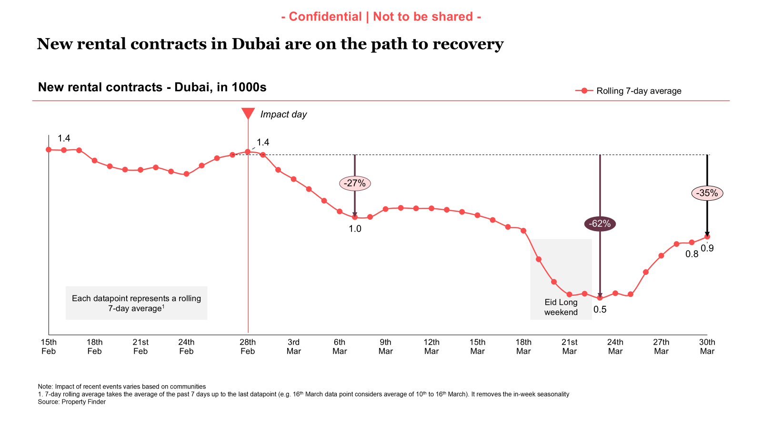

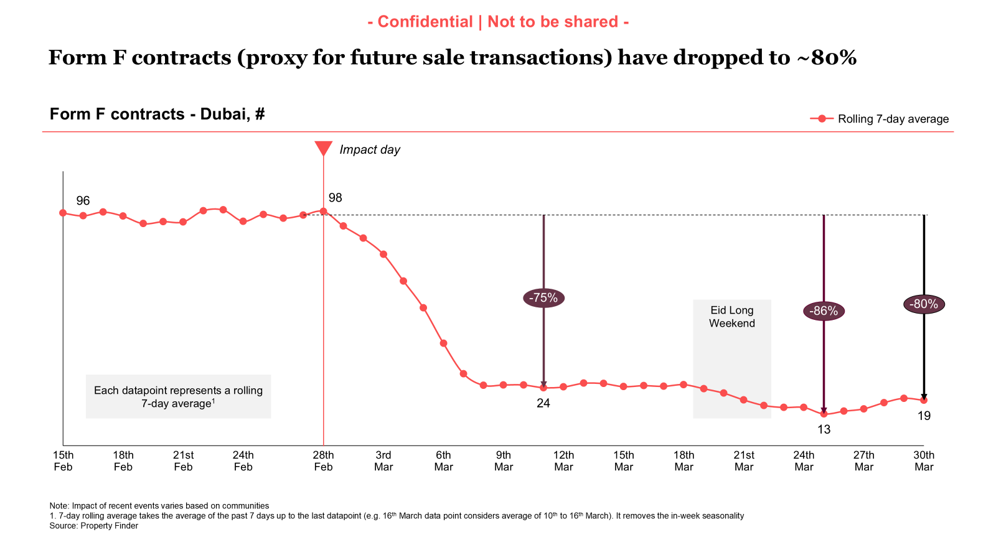

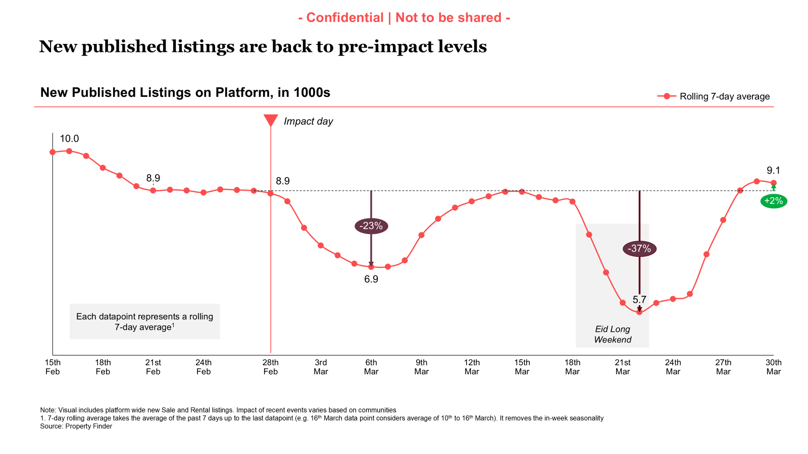

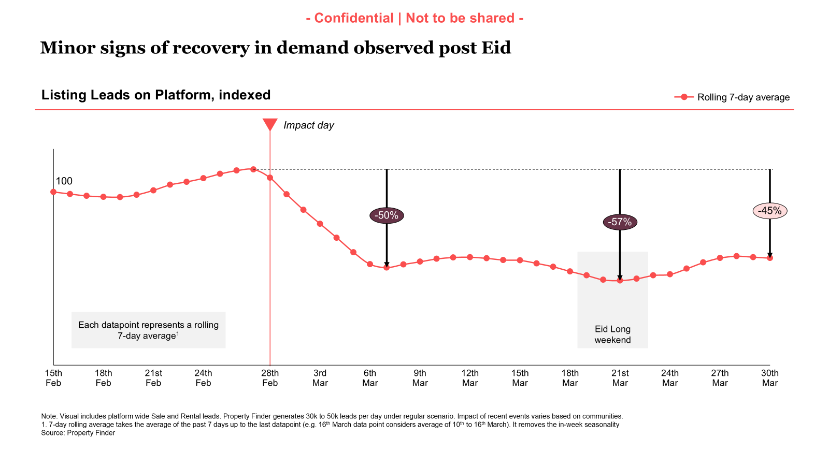

Commercial

Commercial
Category | DRI | Which metric is red and why | Actions planned | ETA for target achievement
Sales forecast % | Vladimir Malugin | March previous view: 95% (with upside to 101%)  CURRENT VIEW:  Will land at 66% FC for March. April FC at 56% (with upside to 60%)  Continuation of hostilities is resulting in more downside, increase in churn and challenging upside. Concerns around cashflow for next few months are still top of client minds | Continued focus through following initiatives, while recognizing key risks:  - Account Plans  - Renewal Narratives  MITIGATION:  - March Relief - in action  - Eid Relief packages - announced last week and in action, >50% of volume (~75% of the value) of book in active conversations  - Anti-crisis broker playbook - shared with BC:  - Leads and deals are not gone - there is less  - Time to nurture them more to close in 2-3 months  - If you are not in the market - you are not competing for sellers and buyers that are here
Exclusive Listings | Michelle Brackley | Competition dashboard for week of 24/03 shows Net Exclusive Listings are down from 24k to 16k  This is a false alarm  - 1The PF CLEL numbers for 10th March and 17th March were understated  - This has most likely happened because of recent scraping challenges as Bayut website having weird behavior (different listing numbers for different users at different times)  - The downward trend in the recent weeks is correct, barring the false positive rise in the week of 10th and 17th March  Bayut have seen an increase of 2.4K between 3rd March and 24th March, we believe this is down to:  - PF Non payers in March kept online until listing expiry but not given March credits, therefore can only list new / renew listings on Bayut  - Number of suspended customers or late renewals from March not closing  - Increase from Bayut only customers (60%) | - Increased relief offers for customers that have all Bayut listings on PF  - Potential of additional credits to trial listing in certain communities  - Community ranking Methodology  Owners: Yash/Volkan  Next Steps: Exclusive listings will be incorporated into the ranking methodology for "Top Communities"  ETA: 06/04/2026  - CPL discount on BY Exclusive listings  Owner: Anirudh  Next steps: Update on this needed - design review meeting to be scheduled  - Automatic import of BY Exclusive Listings  Owners: Hugs  Next Steps: Video demo to be sent to BCs and CSPs Friday 27th March. Decision to be made whether we wait for go live to have discounts live. Slack group to discuss offers and whether they are community specific.  ETA: TBC  Go live: 09/04/2  - Milestone Driven Benefits  Owner: Hugs  Next Steps: Initial Proposal  ETA: 01/04/26  - Align on Communities to target for performance marketing campaigns:  Owners: Mahmoud/Michelle  Next steps: Meeting set up  ETA: 30/03/26  - Compass & data narrative:  Owner: Aksinia  Next steps: Design and content agreed on, now being built  ETA: 10/04/26  - Non-compliant listings:  Alignment on communication flow.  Implementation being planned  Lina and engineering to meet to understand timelines and process fully.  Implementation to start  ETA: 03/04/26

Weekly Metrics
 |  | Weekly |  |  |  | MTD (Feb)
Category | Metric | Week  (Actual) | Week (Target) | WoW | vs 2 weeks prior | MtD  (Forecast) | Month (Target) | vs MtD  prev month (MoM) | vs MtD  prev year (YoY) | vs competition | DRI | Dash
Sales  (MtD) - UAE | Sales Forecast %  (Month-end) | Monthly -> |  |  |  | 46.4M  (66%) | 70.7M | Not Applicable | Not Applicable | Not Applicable | Vladimir Malugin | Link

CLEL to not be discussed in Q1, till baseline is defined and Product actions are in place

Category | Metric | Week  (Actual) | Week (Target) | WoW | vs 2 weeks prior | MtD  (Actual) | Month  (Target) | vs MtD  prev month (MoM) | vs MtD  prev year (YoY) | vs competition | DRI | Dash
Net exclusive listings | Rent | NA | NA |  |  | NA | NA | NA | NA | Not Applicable | Michelle Brackley
 | Sale | NA | NA |  |  | NA | NA | NA | NA | Not Applicable | Michelle Brackley
Supply | Net Exclusive Listings | NA | NA |  |  | NA |  | NA | NA | Not Applicable | Michelle Brackley
Supply |  | NA |  |  |  |  |  |  |  |  | Person

Total Listings

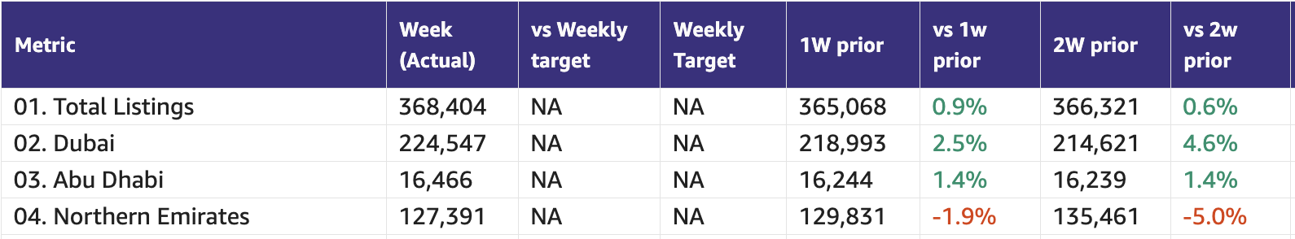

Primary (NP, Media, Dev)

Primary (New Projects, Media Sales)
Category | DRI | Which metric is red and why | Actions planned | ETA for target achievement
New Projects | Enguerran Milhiet | - All metrics red, impact of lower demand due to conflict. | - Similar to previous weeks: we continue to deliver on our roadmap. | Expected for March  - Sessions: 60%  - Sold leads: 75%  - Revenue: 95%
Media & Developers | Sami Awada | - Budgets are on hold until further notice | - Pushing delivery on live campaigns | - Forecast 41%, Gross Sales at 37% with an upside of 400k AED (54%)

Category | Metric | Week  (Actual) | Week (Target) | WoW | vs 2 weeks prior | MtD  (Actual) | Month  (Target) | vs MtD  prev month (MoM) | vs MtD  prev year (YoY) | vs competition | DRI | Dash
New Projects | Sessions | 50.5k | 87k | -14.3% | +16.7% | 156,450 | 385,454 | -37.5% | -51.2% |  | Enguerran Milhiet
 | Sold Leads | 1,302 | 1,787 | -13.7% | +21.2% | 4,015 | 7,910 | -31.1% | +19.7% |  | Enguerran Milhiet
 | Gross Revenue (USD) | $116.2k | $130.6k | -13.7% | +3.9% | $374.6k | $578.2k | -29% | +34.9% |  | Enguerran Milhiet
Media & Developer | Revenue from Media Products | NA | NA | NA | NA | Monthly |  |  |  |  | Sami Awada

Demand (Paid/Unpaid)
+
Demand
Category | DRI | Which metric is red and why | Actions planned | ETA for target achievement
Paid | Ahmed Osman | - All Metrics are down due to the conflict. | Summary (31 Mar 2026):  - Demand: Sessions index is currently [XX] (baseline = 100). The decline continues to be driven by Eid al-Fitr seasonality (Mar 20 onward), consistent with prior years. Normalisation expected from Apr 2 onward. Tracking pull channels only — organic search, paid search, and app sessions.  - New Projects Sellable Leads: Increase MoM by +109% driven by lower competition activity.  - Spend: The last 7-day average is back at pre-escalation levels, up +25% WoW. This reflects deliberate bid and budget experiments we ran during the month to map competitor behaviour and test the limits of the auction (detailed below). March overall average remains lower, driven by the scaling-down period in early March.  - Leads: Paid leads for the week of Mar 23–29 are up +24.2% WoW, tracking directly with the spend increase from our experiments. March MtD is below February, driven by a combination of lower early-March spend and Eid seasonality. Not a structural signal.  Competitive — Bayut escalation and our competitive intelligence:  - Bayut has now escalated across most non-brand categories. Core Buy SOV (W11) sits at 51.9% (-1.3pp WoW). Core Rent SOV (W11) sits at 55.3% (-1.4pp WoW). Bayut's Absolute Top-of-Page rate remains elevated at 88.9% on Core Buy and 90.6% on Core Rent.  We ran two deliberate bid and budget experiments this month, specifically to understand competitor behaviour and confirm the boundaries of the auction:  - Mar 19: We increased Core Buy spend for one day. PF impression share jumped +10.55pp (51.26% → 61.81%). Our lead over Bayut expanded from +6.7pp to +11.8pp overnight. We chose to step back the next day. Result confirmed: we can reclaim full Core Buy paid SOV in 24 hours when we want to.  - Mar 30 (yesterday): Without any change on our side, Bayut's Core Buy impression share dropped 3.7pp. Our lead expanded from +2.2pp to +5.2pp in one day — confirming they are not holding a stable position either.  These experiments confirm we are not being pushed into a lower position. We know exactly where the ceiling and floor of this auction are.  Next Steps:  - Paid Search: April strategy is set. On Core Buy, we hold a deliberate maintenance position — we have proven we can step up in 24 hours and we will do so when market conditions justify it. On Core Rent, where our organic coverage is weaker, we defend aggressively. No change to Core Rent investment.  - Paid Social: Scaling up significantly in April. Most efficient lead generation channel in the mix by a wide margin — every incremental dollar goes here first.  - Programmatic Display: Reactivating gradually in April on a brand-safe and brand-suitable basis after a period of pause.  - Core Rent SOV trigger: Pre-agreed — if Core Rent SOV drops below 55% at any point in April, we shift budget from Core Buy to Core Rent immediately.  - Demand normalisation: First post-Eid week data expected from Apr 2. April strategy will be reassessed at the next WBR with that data in hand.
Unpaid - SEO | Mahmoud Nessim | - SEO SoV is showing a steady growth WoW on weekly avg, scoring highest on the ~49%, dominated by growth on Rent and generic keywords,  - Internal number of sessions and leads are down against target due to war, having the competitive metrics showing a healthy market penetration is a good indicator,  - We’re seeing some slow recovery driven by “for sale” properties, we started at losses of ~ 29% now we’re at -25.21%, while on sale we’re at -22.29% and rent we’re at -38.56% for the now ( rent started to decline further* ) | - Deeper analysis on the recovery either or not the growth that Bayut is doing is due to their massive budget shifts ( Ahmed Osman ), the decrease in rent is it still reflective to the market dynamics or a competitive outperforming ( the SoV doesn’t translate the same )  - Working on the actions prioritized for rentals ( listings gap, 4 top communities identified, and total list of + 15 )  - Working on content revamps for SERPs  Coming releases:  - The Price drop feature  - The UGC on SERPs & New projects | - Content revamps ( Already in action, and by next week we’ll have visibility )  - UGC ( This week, early next week )  - Listings acquisition ( Planned ongoing work, Michelle Brackley will come back with findings this week )
Unpaid - Overall | Soumar Aoun | We’re seeing early recovery in Share of Sessions, now only -1.3pp below target (+2.4pp WoW), fully driven by strong App momentum. App is now above target, with consistent growth across iOS and Android, although Android remains structurally down YoY.  However, this recovery is not yet healthy or balanced. Web continues to underperform (-5pp vs target) and is recovering slower than Bayut, making it our primary gap in winning share.  At the same time, demand and leads remain significantly below target. While sessions are starting to recover, leads are lagging due to a clear drop in conversion rate across all channels, largely impacted by the current regional context.  We’re also seeing a shift in traffic quality — paid sessions are up (driven by retargeting), but not translating into leads, further pressuring conversion.  Overall, the story is clear:  Traffic is starting to recover, App is leading, but conversion is the core issue, and Web remains the key battleground |  Ramping Up (Experiments → Scale)  - SERP Revamp (Web) → ramped to 100%   Shipping This Week (Structural Impact)  - App Homepage  - Web Homepage  - Profile Stitching & Completion → unify Email + WhatsApp under same profile  - Price per Area Filter (Apps) → 01/04  - Market urgency: We’re moving from a listings marketplace to a decision-making engine — shifting from showing prices to showing true value vs market, powered by real-time comparable data. We surface what’s actually a deal (not just a price drop), explain why, and make it impossible for users to miss — directly on the core journeys (SERP, PLP, CRM).  A deal is a property priced materially below what comparable homes are currently asking in the market — not below its own previous price.  We benchmark each listing against like-for-like properties (same location, type, size, bedrooms, etc.) using live market data.  To qualify, it must pass two gates: (not finalized)  - Absolute discount vs market (e.g. ≥10% below median of comparable listings)  - Price per sqm also below the market range (to avoid large units looking artificially cheap)  We also ensure data integrity and anti-gaming — filtering out outliers, unstable prices, duplicates, and thin supply — so the signal holds up.  👉 Net: if a user can buy this property cheaper than equivalent options available right now, it’s a deal. | - This week  - This weekMarket urgency in two weeks
Exposure LPL | Paresh Goyal | Note: Comparisons below are made vs prev. MTD (pre-geopolitical impact) rather than targets, as Q1 targets are not fully reflective of current market conditions.  - Rent  - Rent eLPL decline (-41%) is broadly in line with overall platform LPL decline (-46%), primarily driven by a sharp drop in leads (-43%), while listings have remained largely flat (minor decline,-3%).  - Buy  - Buy eLPL decline (-45%) vs prev. month is broadly in line with overall platform LPL decline (-54%), primarily driven by a sharp drop in leads (-51%) | - Q2 eLPL targets to be reset, timeline delayed due to ongoing situation  - CRM: Search Re-engagement – Biased Exposure Listings (for Push and Email) is delayed to mid April (due to prioritization changes)

1. SoV - SEO

Metric | Week (Actual) | 1W prior | vs 1W prior | 2W prior | vs 2W prior | MtD (Actual) | MtD PM | vs MtD PM
Total | 45.8% | 45.8% | 0.0 | 45.3% | 0.5 | 45.4% | 41.6% | 3.8
Buy | 63.8% | 62.7% | 1.1 | 63.0% | 0.8 | 60.8% | 66.2% | -5.4
Rent | 53.3% | 53.1% | 0.2 | 53.8% | -0.5 | 51.7% | 48.3% | 3.4
Generic | 35.4% | 32.9% | 2.5 | 32.7% | 2.6 | 33.6% | 29.1% | 4.5

2. Share of Sessions
Platform | This week | March target | Last week | vs last week | 2 weeks | vs 2 weeks | MTD | Last month | vs last month | Last year | vs last year
Total | 52.3% | 53.9% | 49.9% | 2.4 | 49.6% | 2.7 | 50.6% | n/a |  | 56.3% | -5.7
Web | 45.2% | 50% | 48.3% | -3.1 | 49.7% | -4.5 | 47.7% | 50.8% | -3.1 | 54.2% | -6.5
App | 57.1% | 55.9% | 51.0% | 6.1 | 49.6% | 7.5 | 52.6% | n/a |  | 58.7% | -6.1
MoM comparison for App & Total SoS is removed as it had data anomaly issues

App

Device category | This week | March target | Last week | vs last week | 2 weeks | vs 2 weeks | MTD | Last month | vs last month | Last year | vs last year
IOS | 54.3% | N/A | 48.5% | 5.8 | 48.1% | 6.2 | 50.4% | n/a |  | 51.1% | -0.7
Android | 59.1% | N/A | 52.7% | 6.4 | 50.6% | 8.5 | 54.1% | n/a |  | 63.2% | -9.2
MoM comparison is removed as it had data anomaly issues

Share of App DAU
Device category | This week | March target | Last week | vs last week | 2 weeks | vs 2 weeks | MTD | Last month | vs last month | Last year | vs last year
App (Total) | 57.3% | N/A | 51.8% | 5.4 | 52.7% | 4.5 | 51.6% | n/a |  | 54.0% | -2.3
IOS | 54.0% | N/A | 48.6% | 5.4 | 49.5% | 4.6 | 48.5% | n/a |  | 46.6% | 1.9
Android | 59.3% | N/A | 53.8% | 5.4 | 54.8% | 4.5 | 53.6% | n/a |  | 58.3% | -4.6
MoM comparison is removed as it had data anomaly issues

3. Demand Funnel
Web-Paid
Web–SEO (SEO blog sessions are not included)
Web-Direct
App-Total

Exposure LPL

Category | Metric | Week  (Actual) | Week (Target) | WoW | vs 2 weeks prior | MtD  (Actual) | Month  (Target) | vs MtD  prev month (MoM) | vs MtD  prev year (YoY)
Exposure LPL (scaled to 30 days) | Rent | 7.1 | (-35.5%)  11.0 | (-21.1%)  9.0 | (-9.0%)  7.8 | 7.8 | (-29.1%)  11.0 | (-42.2%)  13.5 | (-35.5%)  12.1
 | Sale | 3.7 | (-51.3%)  7.6 | (-26.0%)  5.0 | (-17.8%)  4.5 | 4.3 | (-43.4%)  7.6 | (-45.0%)  7.82 | (-48.8%)  8.4

Rent/Buy leads

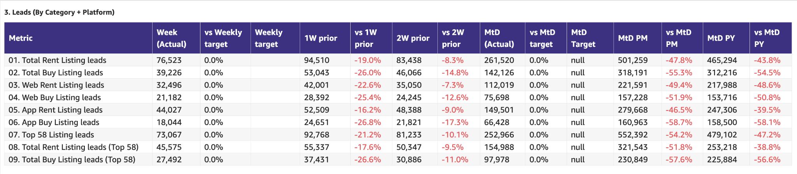

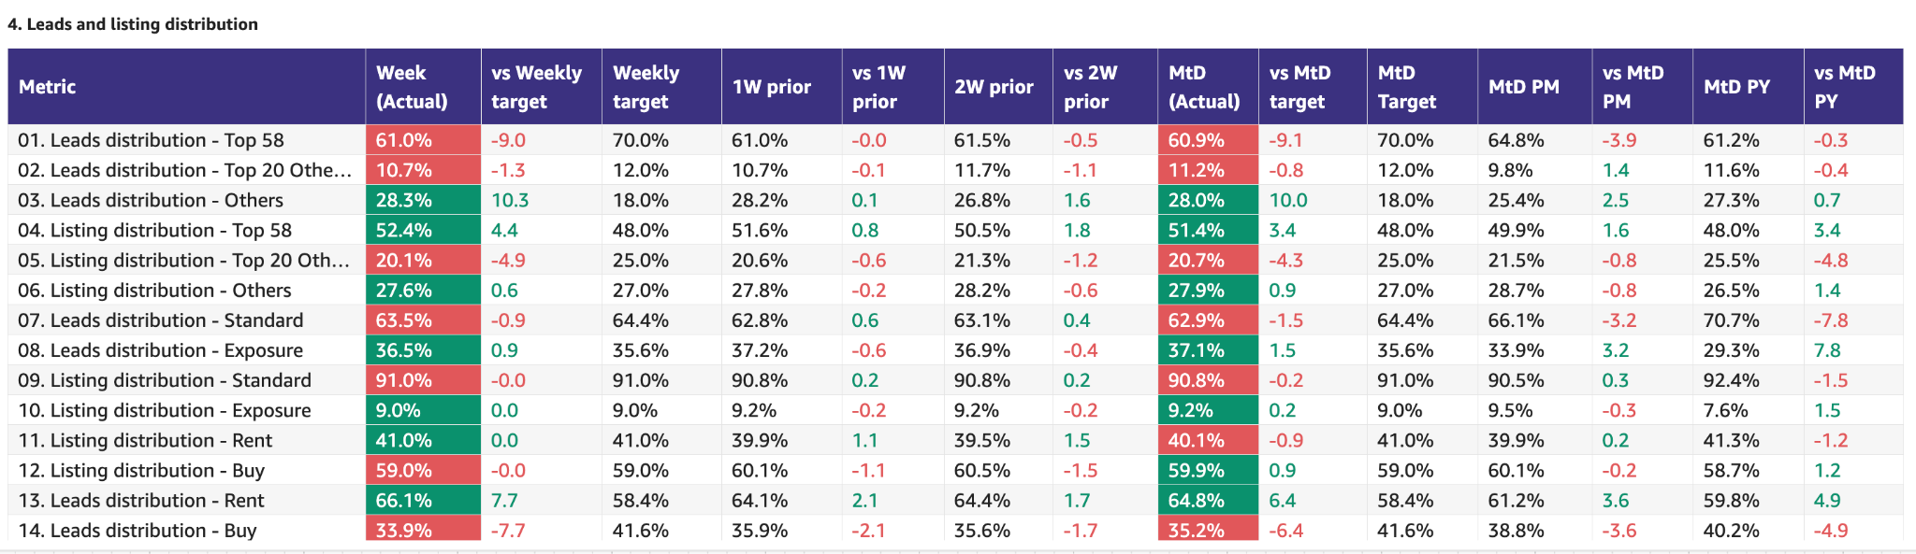

Monthly Metrics

B2C NPS
Category | Metric | MtD  (Actual) | Month (Target) | vs MtD  prev month (MoM) | vs MtD  prev year (YoY) | vs competition | DRI | Dash
B2C NPS | B2C NPS | 4 | Not Available | 3 | 19 | Not Available | Alson Dsouza

Leads click to delivered (monthly metric):
Category | Metric | MtD  (Actual) | Month (Target) | vs MtD  prev month (MoM) | vs MtD  prev year (YoY) | Δ vs Competition | DRI | Dash
Leads Funnel | Total Leads Delivered (WA) |  |  |  |  | Not Available | Soumar AounSruthi Poduval | Link
 | % Clicks to Delivered (WA) |  |  |  |  | Not Available | Soumar AounSruthi Poduval | Link
 | Error Leads (WA) |  |  |  |  | Not Available | Soumar AounSruthi Poduval | Link

PR Metric
Category | Metric | MtD  (Actual) | Month (Target) | vs MtD  prev month (MoM) | vs MtD  prev year (YoY) | vs competition | DRI | Dash
PR | PR Sov | 100% | 50-55% |  | [...] | [...] | Natalie Faulkner | PR team

- Competition
  - Share of Session (Overall, Web Channels, App Channels)
  - SoV - Paid click share

- Demand Funnel
  - Sessions (by channels)
  - Leads (by channels)
  - CR (by channels)
  - Click to Delivered

- Exposure LPL
  - Overall / Rent / Sale
  - Top Communities
  - Web/App
  - Exposure Leads as % of Total Leads (Overall / rent / sale)
  - Exposure Listings (Overall / rent / sale)

- Engagement Metric (Time on site)
- PR SoV - We remain firmly in green as we are endorsed by wider conversations from investors, such as Mubadala - this is the perfect storytelling endorsement, when 3rd parties talk about how important we are to the UAE ecosystem
- Leads split by Rent vs Buy

Data Governance

DATA GOVERNANCE
Problem Name | Problem Description | Latest update | Resolution update (ETA) | DRI
App:  Kochava vs Redshift | Sessions, leads, installs and users in Reshift do not match the same in Kochava | UAE  Session & leads - fixed  Users & installs - under investigation  Int  Session & leads - under investigation  Users & installs - under investigation | n/a | DE: Uday Kasetty  BA: Xueshan Zou
Web:  GA4 vs Redshift | Sessions and leads channel breakdown in Redshift not matching GA4  Users in Redshift not matching GA4 | UAE - fixed  Int - under validation | n/a | DE: Aamir Shaiq  BA: Mohamed Hamed
CRM Attribution Reporting | Braze traffic not matching Kochava for Android | Push notifications  - iOS - fixed  - Android - under investigation  Email campaigns - not started (pending Android fix)  WA campaigns - not started (pending Android fix) | n/a | B2C: Abdullah Shah  MarTech: Wael Abdella

B2C App Engagement

B2C App
Category | DRI | Which metric is red and why | Actions planned | ETA for target achievement
App engagement & installs | Ahmed Osman | - N/A - Green | - Scoping the estimated effort/resources to gain the leadership for the Android apps category rankings. Scale-up is already taking place.  - Current Rankings (AE-Google Play):  - Bayut:93  - Property Finder: 245
App ratings | Soumar Aoun | - App ratings saw an uptick on Android due to removal of 3 star spam ratings by Google - we also saw an increase in 5 star ratings based on updates made on ratings solicitation.  - Ios app ratings are stabilising we are not getting new negatives in the week and saw 0.11% increase in total 5 stars | - Continue with delayed solicited response | - Q2’26

Weekly Metrics -
App ratings

 |  | Weekly |  |  |  | MTD
Category | Metric | Week  (Actual) | Week (Target) | WoW | vs 2 weeks prior | MtD | Month (Target) | vs MtD  prev month (MoM) | vs MtD  prev year (YoY) | vs competition | DRI
B2C App | Installs | 23.4K | (+66%)  14.1K | (-13.7%)  27.1K | (-11%)  27.3K | 81.4K | (+84%)  44.2K | (-25%)  108.5K | (+39.4%)  58.4K |  | Sanidhya Nanavati

App Rankings

Device Category | Ranking Category | Company Name | Ranking | 1W prior | Vs 1W prior | 2W prior | Vs 2W prior
Android | General | Bayut | 120 | NA | NA | NA | NA
 |  | Property Finder | NA | NA | NA | NA | NA
iOS | General | Bayut | 87 | NA | NA | NA | NA
 |  | Property Finder | 89 | NA | NA | NA | NA
Android | House and Home | Bayut | 1 | 1 | 0 | NA | NA
 |  | Property Finder | 2 | 2 | 0 | NA | NA
iOS | Lifestyle | Bayut | 3 | 8 | ⬆ 5 | NA | NA
 |  | Property Finder | 4 | 5 | ⬆ 1 | NA | NA

 |  | Weekly |  |  |  | MTD
Category | Metric | Week  (Actual) | Week (Target) | WoW | vs 2 weeks prior | MtD | Month (Target) | vs MtD  prev month (MoM) | vs MtD  prev year (YoY) | vs competition | DRI
B2C App | DAU | 51.6K |  | (-0.6%)  51.9K | (+15.7%)  44.6K | 48.9K |  | (-20.6%)  61.6K | (-9.3%)  53.9K |  | Sanidhya Nanavati
B2C App | WAU | 196.2K |  | (+5.1%)  186.6K | (+3.8%)  189.1K | 191.9K |  | (-14.4%)  224.3K | (-3.4%)  198.6K |  | Sanidhya Nanavati
B2C App | MAU | 438.8K |  | (-1.9%)  447.1K | (-4.9%)  461.4K | 450.3K |  | (-4.0%)  469.0K | (-5.0%)  475.4K |  | Sanidhya Nanavati

- App Installs
- App MAU
- App DAU
- App WAU
- Android Playstore ranking (Overall and in specific category) vs Bayut
- iOS Appstore ranking (Overall and in specific category)
- DAU/MAU
- Sessions / DAU
- Login Ratio
- Avg Session Duration
- Playstore rating (Android)
- Playstore rating (iOS)

B2C Tech Metrics

B2C App
Category | DRI | Which metric is red and why | Actions planned | ETA for target achievement
App stability & performance | Taran Kambow | - Both Appdex in green
Web Stability & Performance | Amory Kelie | Mobile INP Good Rate is 72.5%, above the 72% target (+0.5pp WoW).  This reflects sustained performance improvements across search templates, particularly Search Landing and Search Results pages, which drive the majority of user interactions.  Over the past 6 weeks, focused optimization on these surfaces has reduced interaction latency and stabilized performance.  The metric is now stable above target, with no systemic degradation observed across core templates. | • Maintain performance stability on search templates (Landing + Results)  • Enforce performance budgets on all high-traffic interaction surfaces  • Tighten governance on experiments, feature flags, and JS injections  • Continue daily monitoring of INP across top templates  • Extend performance optimizations to secondary templates to support progress toward 75% | - Focus now on maintaining stability and progressing toward 75% by end of Q2

 |  | Weekly |  |  |  | MTD
Category | Metric | Week  (Actual) | Week (Target) | WoW | vs 2 weeks prior | MtD  (Forecast) | Month (Target) | vs MtD  prev month (MoM) | vs MtD  prev year (YoY) | vs competition | DRI | Dash
Tech stability & Performance | Mobile INP Good rate (%) | 72.5 | 72 | +0.5 | +2.3 |  |  |  |  |  | Amory Kelie

- Appdex: Android
- Appdex score: iOS
- CWV

B2B Product

B2B
Category | DRI | Which metric is red and why | Actions planned | ETA for target achievement
CSAT  (Incident Volume) | Luis Cappa | Incident volume under control and in green. | N/A
Agent Experience | Sajjad Ahmad | Acquisition of new users is low compared to Feb weekly average, i.e. 111 new users acquired.  However, WAU is impacted, with some positive recovery in the last week, the WAU is down by ~15% compared to last week.  In April, there are 3 app-exclusive features planned, which should positively influence WAU,  - Seller Leads  - Agent Q&A  - Shareable content  New CRM Manager Huzaifa Alihas joined, and will collaborate with us on setting up CRM based acquisition and reengagement strategy, which does not exist today. | 30.03.2026 Agent Insights on Market Situation  Top 5 insights:  1. The market has slowed sharply, but it has not stopped.  The strongest pattern across agents is not a full market freeze, but a split market. Buyer activity is down materially, lead flow from Property Finder & Bayut is materially down, international demand has pulled back, and many buyers are in “wait and see” mode. At the same time, real transactions are still happening, especially for well-priced stock and committed end users, and the AED 40M+ segment appears more resilient than mass-market tickets.  2. There is now a clear disconnect between listing prices and transacting prices.  Described as “two markets” emerging: the advertised market and the transacting market. A meaningful share of headline price drops are not true distress, but the market correcting previously inflated asking prices. In practical terms, sellers are being pushed toward sharper pricing, with negotiations commonly landing 5–11% below ask in stronger segments and materially more in weaker ones, which can be up to 20-25% below the asking price.  3. Buyer mix has shifted towards opportunistic buyers.  The majority of inbound interest is now from buyers hunting for distress, often asking for 20–30% below asking price, and sometimes more. At the same time, serious end users are still present and will transact close to asking price when the home is right and they have been searching for a long time. First-time buyers and international buyers, however, are far more cautious, largely due to job security concerns and sentiment.  4. Off-plan is the most exposed segment right now.  Across the interviews, off-plan came through as the softest part of the market. Off-plan sales are heavily down, driven by the pause in investor sentiment. The only clear stimulus that seems to be working is developer-led incentives: discounts, better payment plans, DLD waivers, and higher broker commissions. Resale villas and high-quality ready stock appear materially more defensible than off-plan apartments.  5. This environment is starting to reshape the agent ecosystem itself.  Newer agents and weaker brokers are under pressure. Agents with limited personal savings, non-existent clientele, or experience only in an upward market are the most vulnerable. This period will separate relationship-led, advisory brokers from transactional brokers. At the same time, agencies are adapting behaviorally: centralizing leads and transactions into stronger profiles, leaning more on referrals, internal commission splits, archived buyers/sellers, and agent-to-agent leads, and asking PF to help preserve exposure and redistribute unattended leads more intelligently. | End of April

Weekly Metrics
 |  | MTD
Category | Metric | MtD  (Actual) | Month (Target) | vs MtD  prev month (MoM) | vs MtD  prev year (YoY) | vs competition | DRI | Dash
CSAT | Incident Volume | P0: 1  P1: 16 | P0: 6  P1: 73 | P0: 2  P1: 27 | P0: 4  P1: 60 | Not Available | Luis Cappa | Link  (JIRA)

 |  | Weekly |  |  |  | MTD
Category | Metric | Week  (Actual) | Week (Target) | WoW | vs 2 weeks prior | MtD  (Actual) | Month (Target) | vs MtD  prev month (MoM) | vs MtD  prev year (YoY) | vs competition | DRI | Dash

Agent Engagement & Experience | App active agents | 11452 | (-19.9%)  14297 | (+0.1%)  11341 | (+2.3%)  11201 |  |  |  | Not Available | Not Available | Sajjad Ahmad | TBA
 | Active users per week (WAU) | 2755 | (-46.5%)  5155 | (-14.7%)  3203 | (-6.0%)  2930 |  |  |  | Not Available | Not Available | Sajjad Ahmad | TBA
 | Agent NPS | NA | NA | NA | NA | Monthly Metric |  |  |  |  | Sajjad Ahmad | TBA

Agent Engagement & Experience | Agent NPS | Monthly Metric |  |  |  |  | Sajjad Ahmad

Listing Quality

Monetization
Category | DRI | Which metric is red and why | Actions planned | ETA for target achievement
Compliance | Saif Al-Amid | - New metric/sub metrics are ready  - Alignment with ELT today  - Will start reporting on them next week  - Overall so far we have removed/corrected via LAT 18K listings | - Batch cleanup/ (resume this week)  - Wrong Locations (vs. DLD permit) - rolled back and will continue this week  - Incorrect Property Size Mandation - mid April  - Prevention of Republication - 7th April  - Price realism - Internal Feedback (this week and next) - Release mid April

Special Projects
Monthly Lookbacks

Converting at risk clients to Promoters Ivan Gregorc Status
- Expected achievement at the end of the quarter. Based on current progress, what’s the estimated achievement rate for the end of Q1 2025?
By end of Q1, we expect to convert 50%+ of Neutral/Detractor clients into Promoters (target= 15 promoters) and protect renewal risk across the Marketing-owned portfolio (20 clients). Assuming delivery on Product-dependent items.
Current status: 🟢Promoters: 9 🟡Neutral: 9 🔴Detractors: 2
- Achievement (till date) : Indicate completed and pending tasks.
- Client sentiment baseline established and tracked weekly
- Identified top 6 elements to turn Neutral clients into promoters
- Active engagement in place for all Target clients
Pending:
- Impediments : If applicable, what is delaying the progress?
- The majority of blockers are Product-dependent
- Some perception issues (Awards, Premium value) require time and repetition to shift
- Initiatives to address impediments: What actions will we take to address the above issues or improve results?
- 5 out of the 6 (SuperAgent Point System, Spam Leads, Split Deals, Agent Engagements,, Cost of Premium Listings) major issues brought up are being addressed by end March
- 1 out of the 6 (Draft listings Listings) was addressed
Link to deep dive document

Special Projects - Q1 OKRs
Keyper Soumar Aoun On Track
- Expected achievement at the end of the quarter. Based on current progress, what’s the estimated achievement rate for the end of Q1 2025?
  - Keyper integration across B2B and B2C flows is in progress, with the majority of core components in active development and the remaining work focused on final CX workflow alignment and commercial enablement.
Core integration is on track for completion by the end of March. A buffer period for end-to-end testing and launch readiness will follow, with go-live expected no later than 15 April 2025 with overall progress reaching ~95% completion by the end of Q1 2025.
- Achievement (till date) : Indicate completed and pending tasks.
  - 3 agencies selected for MVP launch
  - ~50% of Keyper implementation delivered and the rest is under progress
  - The CX team is working towards a joint CX workflow plan with Keyper.
  - Legal review of key agreements within the flow is ongoing.
- Impediments : If applicable, what is delaying the progress?
  - Design and development capacity constraints have impacted the pace of the integration.

- Initiatives to address impediments: What actions will we take to address the above issues or improve results?
  - Additional contractors onboarded to the B2C team to increase capacity and accelerate delivery
  - Prioritization of core integration components to ensure critical functionality is delivered on schedule

Bundles Paresh Goyal On Track
- Expected achievement at the end of the quarter. Based on current progress, what’s the estimated achievement rate for the end of Q1 2025?
  - MVP Product will be ready for launch in March
  - Pilot sales has been intentionally pushed out, given current market and client situation
- Achievement (till date) : Indicate completed and pending tasks.
  - Development work progressing on-track but with some impact from salesforce migration
- Impediments : If applicable, what is delaying the progress?
  - Salesforce system has just come back online and hence, salesforce development work had paused
  - Expected impact of 2-3 days in completing salesforce development and hence, delay in go-live from 24th March to 26th March
- Initiatives to address impediments: What actions will we take to address the above issues or improve results?
  - Working towards an approach to sign paper contracts for bundles and a potential way to manually switch on bundles for such clients

📋 Prev Saved Reports

Week | Date | Link
Week 11 | Mar 9 to 15 | WBR - Week 11 (Saved Report) Metric Report
Week 10 | Mar 2 to Mar 8 | WBR - Week 10 (Saved Report) Metric Report
Week 9 | Feb 1 to Feb 28 | WBR - Week 9 - Feb Monthly Lookback (Saved Report) Metric Report
Week 8 | Feb 16 to Feb 22 | WBR - Week 8 (Saved Report) Metric Report
Week 7 | Feb 9 to Feb 15 | WBR - Week 7 (SAVED) Metric Report
Week 6 | Feb 2 to Feb 8 | WBR - Week 6 (Saved) Metric Report
Week 5 | Jan 1 to Jan 31 | WBR - Jan Monthly Lookback (Saved Report) Metric Report
Week 4 | Jan 19 to Jan 25 | WBR - Week 4 (Saved) Metric Report
Week 3 | Jan 12 to Jan 18 | WBR - Week 3 (SAVED) Metric Report
Week 2 | Jan 5 to Jan 11 | WBR - Week 2 (SAVED) Metric Report
Year End.
W52 | Dec 1 to Dec 30 | WBR Metric Report - Dec Monthly Lookback (Saved Report)
W49 | Dec 1 to Dec 7 | WBR Metric Report - Week 49 (Saved Report)
W48 | Nov 1 to Nov 30 | WBR Metric Report - Week 48 - Nov Monthly Lookback (Saved Report)
W47 | Nov 17 to Nov 23 | WBR Metric Report - Week 47 (Saved Report)
W46 | Nov 10 to Nov 16 | WBR Metric Report - Week 46 (Saved Report)
W45 | Nov 3 to Nov 9 | WBR Metric Report - Week 45 (Saved Report)
W44 | NA | NA
W43 | Oct 1 to Oct 31 | WBR Metric Report - Week 43 - Oct Monthly Lookback (Saved Report))
W42 | Oct 15 to Oct 21 | WBR Metric Report - Week 42 (Saved Report)
W41 | Oct 8 to Oct 14 | WBR Metric Report - Week 41 (Saved Report)
W40 | Oct 1 to Oct 7 | WBR Metric Report - Week 40 (Saved Report)
W39 | Sep 1 to Sep 30 | WBR Metric Report - Week 39 (Saved Report)
W38 | Sep 17 to Sep 23 | WBR 2.0 Report - Week 38 (Saved Report)
W37 | Sep 10 to Sep 16 | WBR 2.0 Report - Week 37 (Saved Report)
W36 | Sep 3 to Sep 9 | WBR 2.0 Report - Week 36
W35 | Aug 1 to Aug 31 | Copy of WBR 2.0 Report - Week 35.docx
W34 | Aug 20 to Aug 26 | Copy of WBR 2.0 Report - Week 34.docx
W33 | Aug 13 to Aug 19 | WBR 2.0 Report - Week 33.docx
W32 | Aug 6 to Aug 12 | Copy of WBR 2.0 Report - Week 32.docx
W31 | Jul 30 to Aug 5 | WBR 2.0 Report - Week 31.docx

